LAB TASK – 2:  
Submitted by:   
 *SYEDA HADIA BATOOL*

#### Submitted to: *SIR RASIKH ALI* TASK – 1 MINI-PROJECT “DYNAMIC CALCULATOR” *Explanation:* TASK – 1

### **Explanation of the Code**

* **range(1, 101)**: This creates a loop that runs from **1 to 100** (remember, 101 is excluded).
* **number % 3 == 0**: Checks if the number is divisible by 3.
* **number % 5 == 0**: Checks if the number is divisible by 5.
* **number % 3 == 0 and number % 5 == 0**: This condition is checked **first** to make sure numbers like 15, 30, etc., correctly return **Fizz Buzz** instead of just Fizz or Buzz.
* **print(number)**: If none of the conditions match, we just print the number itself.

**OUTPUT OF THE CODE:**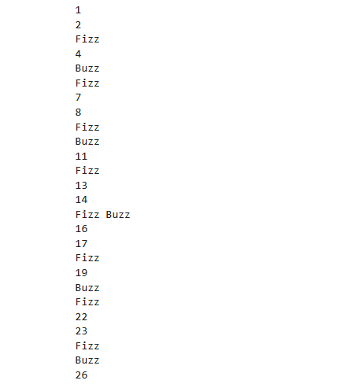

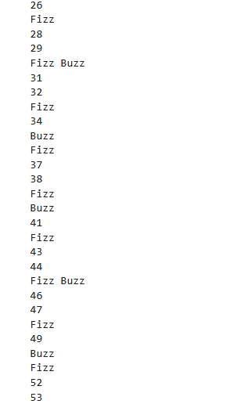

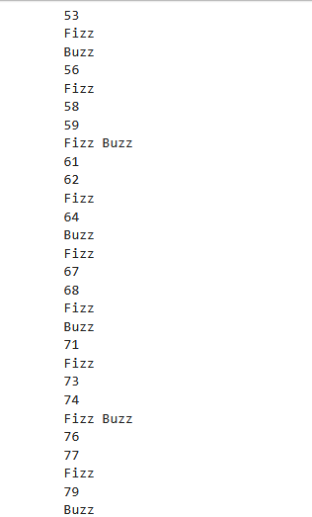

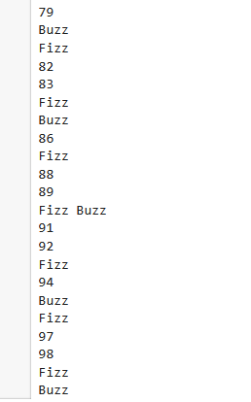

**TASK 2  
EXPALANTION:**• **Data Structure:** We use a list of tuples, where each tuple contains the movie name and its budget.

• Average **Calculation:** We sum all the budgets and divide by the number of movies.

• Comparison**:** For each movie, if its budget > average, we print the movie and the difference.

• User **Input:** Users can add any number of custom movie

### **FEATURES: What the Program Does:**

1. It starts with a list of movies and their budgets.
2. It calculates the **average** budget of all the movies.
3. It checks which movies have a **budget higher than the average**.
4. For each of those high-budget movies, it shows **how much more** their budget is compared to the average.
5. It also **counts** how many movies are above the average budget.
6. **Bonus Feature:** The program gives the user an option to add new movies and their budgets before doing the analysis.

### **Conclusion:**

* **Working with lists and tuples**
* **Using loops and conditionals**
* **Collecting user input**
* Performing **basic math operations**